**E-commerce Application on IBM Cloud Foundry**

**Phase 1:**

**Problem Definition**: The project is to build an artisanal e-commerce platform using IBM Cloud Foundry. The goal is to connect skilled artisans with a global audience, showcasing their handmade products and providing features like secure shopping carts, payment gateways, and an intuitive checkout process. This involves designing the e-commerce platform, implementing necessary features, and ensuring a seamless user experience.

**Problem Solution:**

Artisanal (made in a traditional way by someone who is skilled with their hands) can be connected with a common platform with the global audience, by showcasing products they made like Jewellery, pots, home decors etc.,

We can use IBM cloud foundry services such as App service, Database Service, Cache services and payment Gateway Service. We can also use IBM cloud Foundry’s CI/CD pipeline, monitoring and logging services and security services.

1.Platform Design:

We Use IBM Cloud's web development services and frameworks like Node.js, Express.js, or Python Flask to create an attractive and responsive UI.

2.Product showcase:

We can utilize IBM Cloud Databases for storing product information, including images, descriptions, prices, and categories. We can choose between SQL or NoSQL databases based on our needs.

3.User Authentication:

We can use Single Sign-On (SSO) this Enables SSO using IBM Cloud SSO service for a seamless login experience.

4.Shopping Cart and Checkout:

We can use IBM Cloud Secure Gateway this ensure secure communication between your platform and payment gateways using IBM Cloud Secure Gateway.

5.Payment Integration:

Integrate with payment gateways like IBM Pay, UPI, or PayPal using their respective APIs.

**Development and Deployment:**

Use IBM DevOps services to automate the development pipeline, including code deployment and testing.

Continuously monitor platform performance using IBM Cloud Monitoring and Application Performance Management tools.

Testing and Launch

Thoroughly test the platform, including functionality, security, and user experience.

Conduct a beta launch to gather user feedback and make necessary improvements.

Plan and execute a full-scale launch, considering marketing and promotion strategies to attract artisans and customers.

**Ongoing Maintenance**

Establish a support system to handle customer inquiries and technical issues. Monitor platform analytics to gain insights into user behaviour and sales.

Phase 2:

Aim:

Our objective is to enhance and refine the original design by harnessing the capabilities of machine learning, resulting in a more advanced and precise analytical framework. This innovation will empower us to uncover more profound insights and deliver highly accurate recommendations to support data-driven decision-making.

Innovations:

Machine Learning Model Selection:

* Research and Selection: Conduct in-depth research to identify the most suitable machine learning algorithms for predictive analysis and anomaly detection. Consider algorithms like Random Forest, Gradient Boosting, LSTM for time-series data, and Isolation Forest for anomaly detection.
* Hybrid Models: Explore the possibility of creating hybrid models that combine the strengths of different algorithms, enhancing prediction accuracy.

Shopping using AR Technology:

* Recent estimates from industry experts like Global Newswire indicate that the augmented reality business is booming and expanding faster than nearly any other technology. Here’s how shopping using AR technology is beneficial – Enables customers to visualize products using their smartphones or tablets in a real-world environment.
* Retailers can use AR technology to showcase their products more engagingly and interactively and differentiate themselves from competitors.AR technology can also help reduce return rates, as customers can see how products look and fit before purchasing.
* Shopping using AR technology is an emerging trend in e-commerce that has the potential to revolutionize the way customers shop and interact with retailers.

Predictive Analysis and Anomaly Detection:

* Prediction: Utilize the trained models for predictive analysis to forecast climate trends and social patterns. Generate predictions for future time points based on historical data.
* Anomaly Detection: Implement anomaly detection algorithms to identify unusual patterns or outliers within the data. This is crucial for understanding unexpected events or deviations from regular patterns.

Single-click Checkout:

* Due to the laborious and drawn-out checkout process, transactions usually get lost. About 17% of customers are said to abandon their carts due to a lengthy or difficult checkout procedure. The best way to get over that is to apply single-click checkout. It is a single-page

payment process that is used to process orders. Consumers enter the necessary data, and the payment processor saves their information for future purchases.

Live Shopping Software:

* Since social media has become such an essential part of people's shopping behavior, these tools make it super easy for vendors to sell while they are live on multiple platforms and for customers to purchase during the presentation. The software has great potential and encourages engagement between the two parties.

Buy Now Pay Later (BNPL):

* Buy Now Pay Later (BNPL) is a convenient payment option that enables customers to make online and in-store purchases without paying the full amount upfront. The market’s expansion is driven by factors like digitalization, increased merchant adoption, the growing popularity among younger consumers, and the emergence of new lending players offering BNPL services. Younger consumers particularly favour BNPL services due to the advantages it offers.

Click and Collect or BOPIS:

* Buy online, pick up in-store (BOPIS), or click-and-collect is another one of the current trends in ecommerce technology. This commerce involves buying or reserving a product online and picking it up at a shop or pickup location. For company owners, click-and-collect means less money spent on delivery and more people visiting physical stores.

Chatbots:

* A chatbot (known as a conversational agent), is software technology that imitates real human interaction in a written or spoken way. It can be represented as a website bot, chatbot app, social media chatbot, as well as a voice assistant.

Phase 3 :

PROBLEM STATEMENT:

* Building an artisanal e-commerce platform to connect skilled artisans with a global audience
* This application showcases their handmade products and provides features like
* secure shopping carts, payment gateways, and an intuitive checkout process
* Adding features which enhances Platform Design, Product Showcase, User
* Authentication, Shopping Cart and Checkout, Payment Integration, and User Experience

**CREATING A LOGIN PAGE OR HOME PAGE**

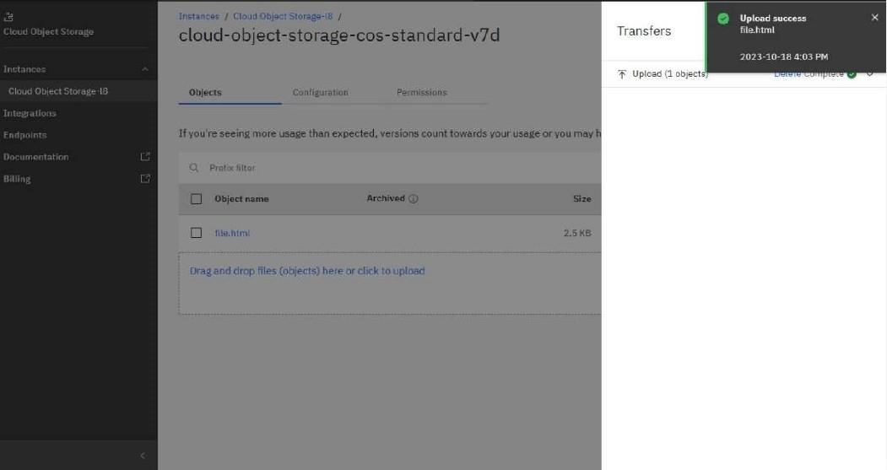

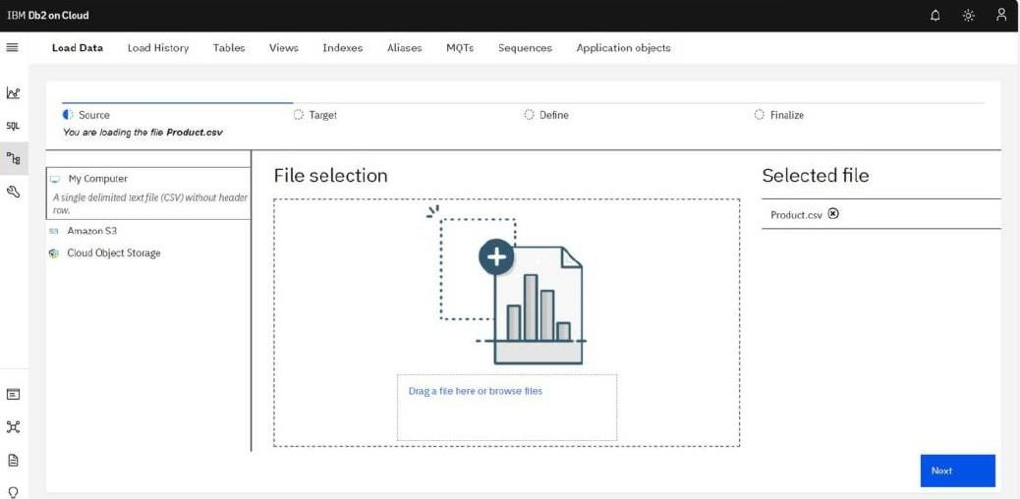

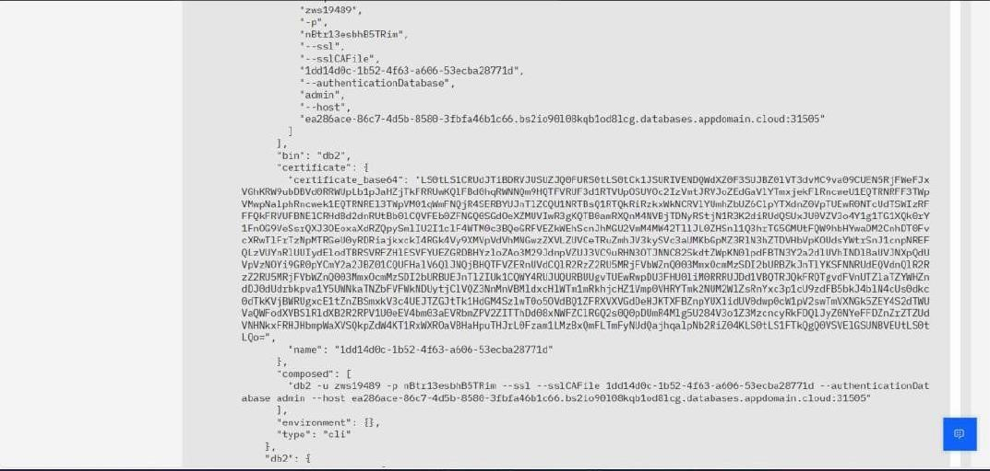

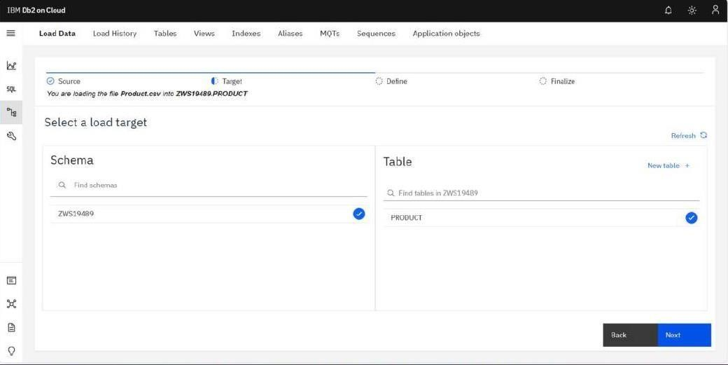

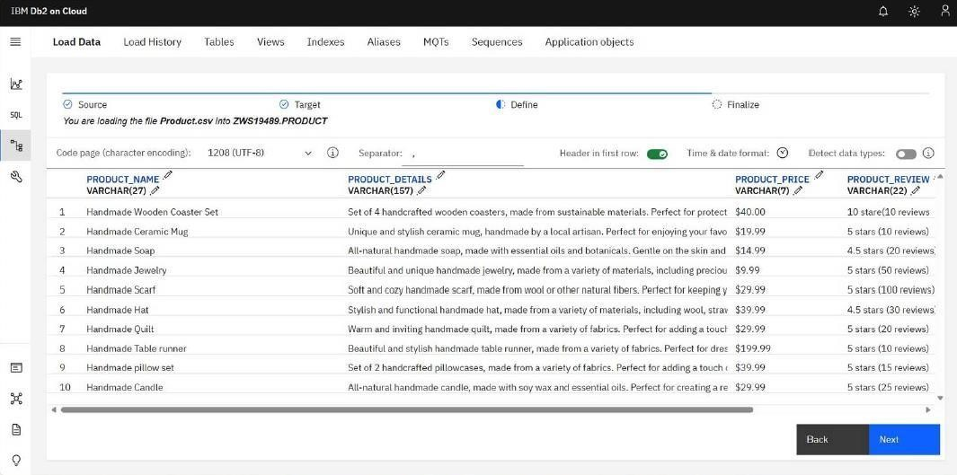

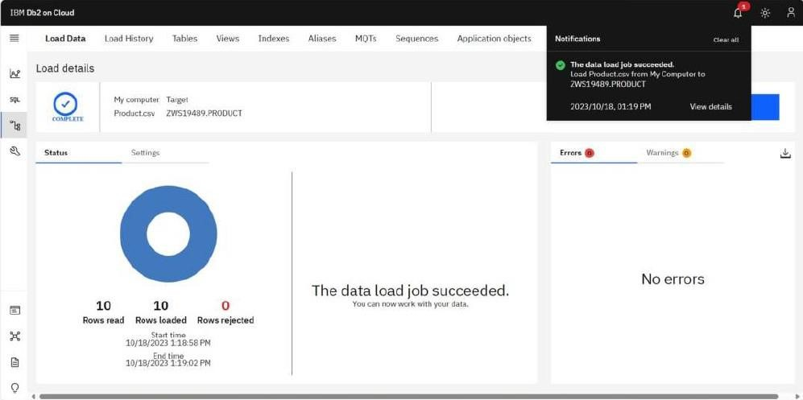

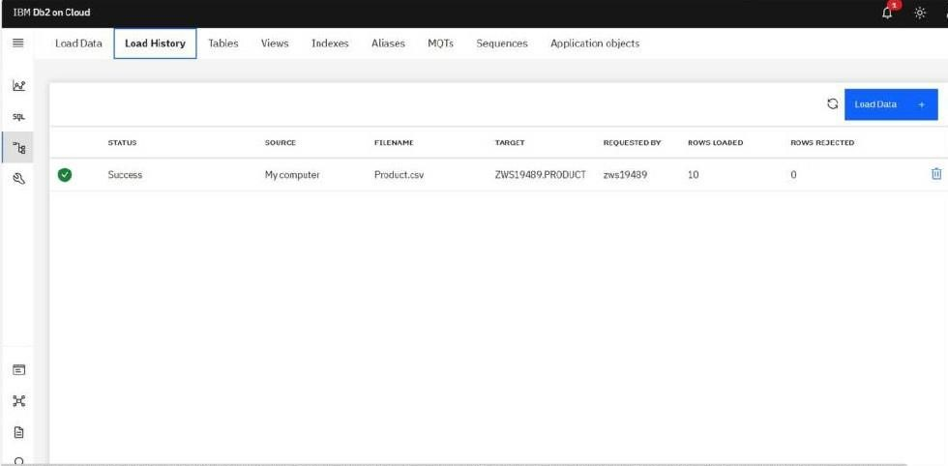

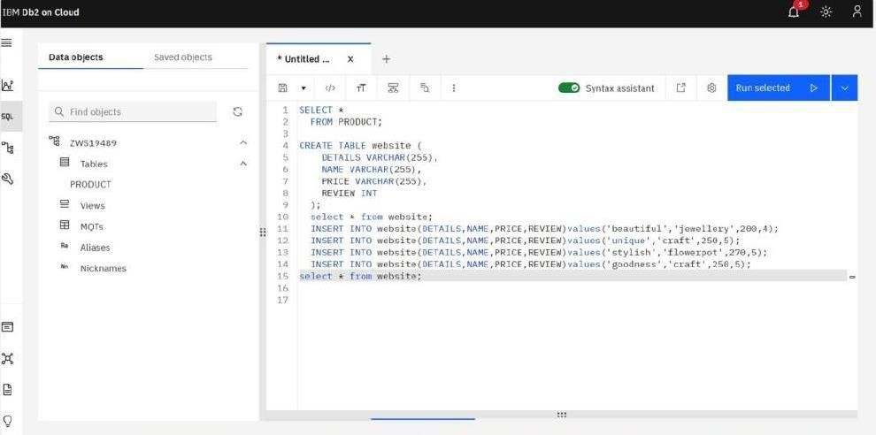

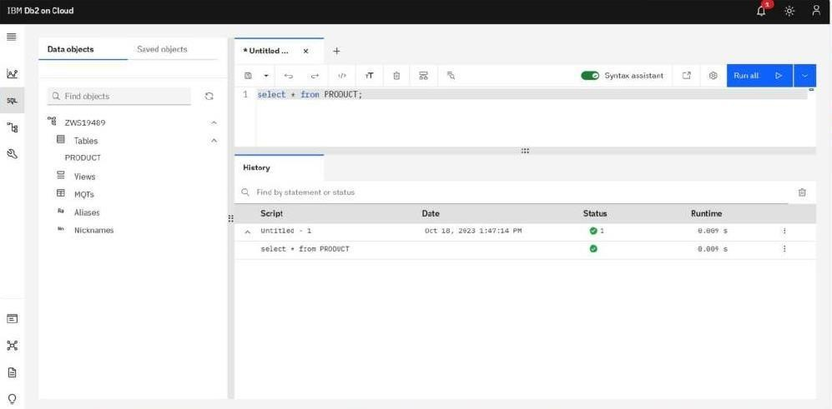

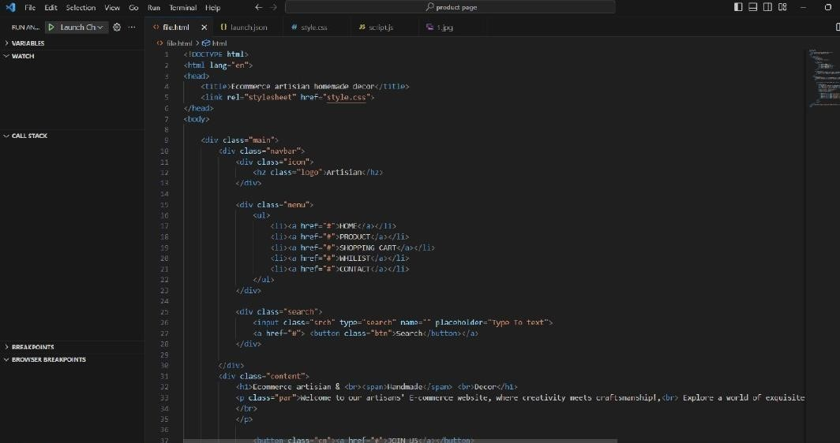

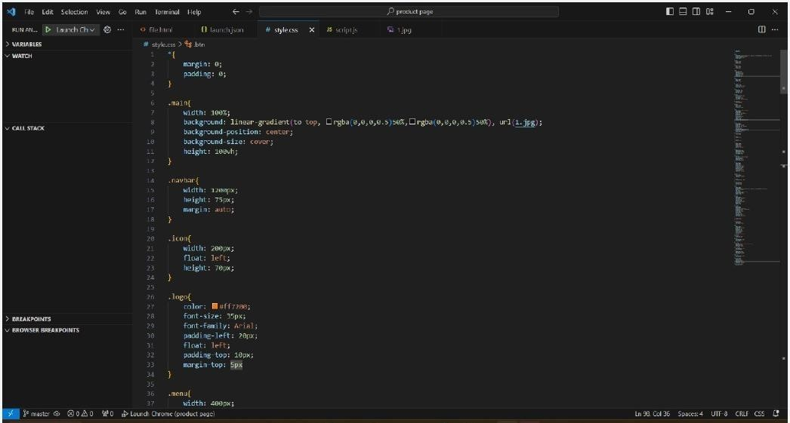

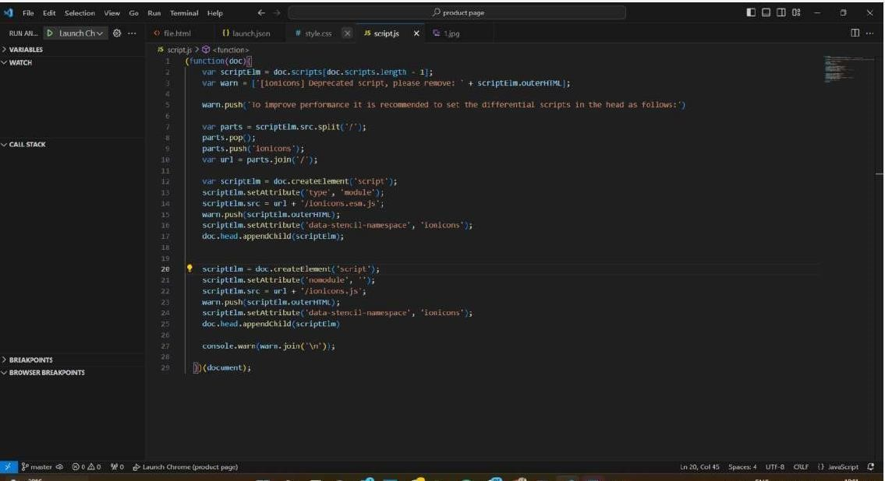

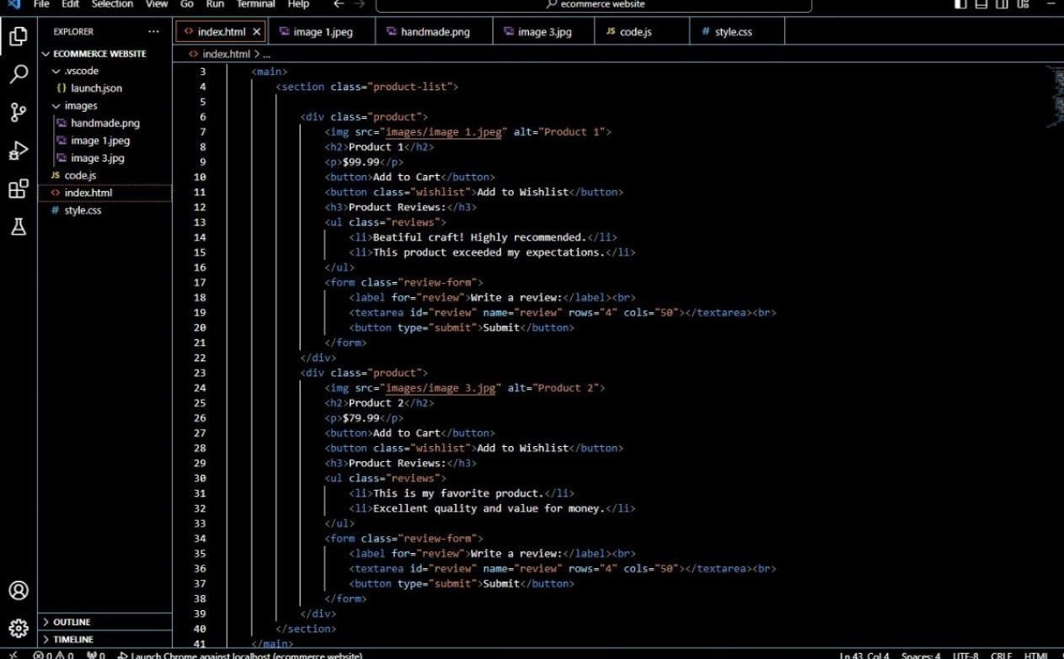

Phase 4:

Code For HEADER

<!DOCTYPE html>

<html lang="en">

<head>

<meta charset="UTF-8">

<meta name="viewport" content="width=device-width, initial-scale=1.0">

<meta http-equiv="X-UA-Compatible" content="ie=edge">

<title> HEADER | E-COMMERCE WEBSITE </title>

<!-- favicon -->

<link rel="icon" href="https://yt3.ggpht.com/a/AGF-l78km1YyNXmF0r3-

0CycCA0HLA_i6zYn_8NZEg=s900-c-k-c0xffffffff-no-rj-mo" type="image/gif" sizes="16x16">

<!-- EXTERNAL LINKS -->

<link rel="stylesheet" href="css/header.css">

<script src="https://kit.fontawesome.com/4a3b1f73a2.js"></script>

<link href="https://fonts.googleapis.com/css?family=Lato&display=swap" rel="stylesheet"> </head>

<body>

<header>

<section>

<!-- MAIN CONTAINER -->

<div id="container">

<!-- SHOP NAME -->

<div id="shopName"><a href="index.html"> <b>SHOPPING</b>DAMAKA</a></div>

<!-- COLLCETIONS ON WEBSITE -->

<div id="collection">

<div id="clothing"><a href="clothing.html"> CLOTHING </a></div>

<div id="accessories"><a href="accessories.html"> ACCESSORIES </a></div> </div>

<!-- SEARCH SECTION -->

<div id="search">

<i class="fas fa-search search"></i>

<input type="text" id="input" name="searchBox" placeholder="Search for Clothing and Accessories">

</div>

<!-- USER SECTION (CART AND USER ICON) -->

<div id="user">

<a href="cart.html"> <i class="fas fa-shopping-cart addedToCart"><div id="badge"> 0

</div></i></a>

<a href="#"> <i class="fas fa-user-circle userIcon"></i> </a>

</div>

</div>

</section>

</header>

</body>

</html>

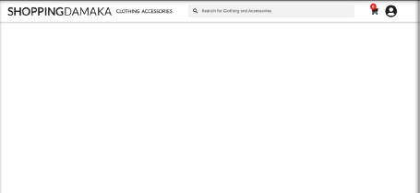

CODE FOR SLIDE:

<!DOCTYPE html>

<html lang="en">

<head>

<meta charset="UTF-8">

<meta name="viewport" content="width=device-width, initial-scale=1.0">

<meta http-equiv="X-UA-Compatible" content="ie=edge">

<title> SLIDER | E-COMMERCE WEBSITE </title>

<!-- favicon -->

<link rel="icon" href="https://yt3.ggpht.com/a/AGF-l78km1YyNXmF0r3-

0CycCA0HLA_i6zYn_8NZEg=s900-c-k-c0xffffffff-no-rj-mo" type="image/gif" sizes="16x16">

<!-- EXTERNAL LINKS -->

<script src="http://code.jquery.com/jquery-3.4.1.min.js" integrity="sha256-

CSXorXvZcTkaix6Yvo6HppcZGetbYMGWSFlBw8HfCJo=" crossorigin="anonymous"></script>

<link rel="stylesheet" href="https://cdnjs.cloudflare.com/ajax/libs/slick-carousel/1.9.0/slick.min.css"> <link rel="stylesheet" href="https://cdnjs.cloudflare.com/ajax/libs/slick-carousel/1.9.0/slicktheme.min.css"> <style> body

{ margin: 0;

}

#containerSlider

{ margin: auto; width: 90%; text-align: center; padding-top: 100px; box-sizing: border-box;

}

#containerSlider img

{ width: 100%; height: 140%; text-align: center; align-content: center;

}

@media(max-width: 732px)

{

#containerSlider img

{ height: 12em;

}

}

@media(max-width: 500px)

{

#containerSlider img

{

height: 10em;

}

}

</style>

</head>

<body>

<section>

<div id="containerSlider">

<div id="slidingImage"> <img src="img/img1.png" alt="image1"> </div>

<div id="slidingImage"> <img src="img/img2.png" alt="image2"> </div>

<div id="slidingImage"> <img src="img/img3.png" alt="image3"> </div> <div id="slidingImage"> <img src="img/img4.png" alt="image4"> </div>

</div>

</section>

</body>

<!-- <script src=“https://cdnjs.cloudflare.com/ajax/libs/slick-carousel/1.9.0/slick.min.js”></script> -->

<script src="https://cdnjs.cloudflare.com/ajax/libs/slick-carousel/1.9.0/slick.min.js"></script> <script>

$(document).ready(function()

{

$('#containerSlider').slick({ dots: true, infinite: true, slidesToShow: 1, slidesToScroll: 1, autoplay: true, autoplaySpeed: 2000,

});

});

</script>

</html>

<!-- SEARCH SECTION -->

<div id="search">

<i class="fas fa-search search"></i>

<input type="text" id="input" name="searchBox" placeholder="Search for Clothing and Accessories">

</div>

<!-- USER SECTION (CART AND USER ICON) -->

<div id="user">

<a href="cart.html"> <i class="fas fa-shopping-cart addedToCart"><div id="badge"> 0

</div></i></a>

<a href="#"> <i class="fas fa-user-circle userIcon"></i> </a>

</div>

</div>

</section>

</header>

</body>

</html>

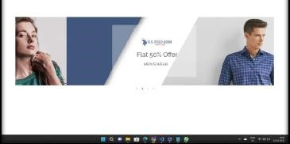

CODE TO ADD ITEMS TO CART:

<!DOCTYPE html>

<html lang="en">

<head>

<meta charset="UTF-8">

<meta name="viewport" content="width=device-width, initial-scale=1.0">

<meta http-equiv="X-UA-Compatible" content="ie=edge">

<title> Cart | E-COMMERCE WEBSITE BY EDYODA </title>

<link rel="stylesheet" href="css/cart.css">

<!-- favicon -->

<link rel="icon" href="https://yt3.ggpht.com/a/AGF-l78km1YyNXmF0r3-

0CycCA0HLA_i6zYn_8NZEg=s900-c-k-c0xffffffff-no-rj-mo" type="image/gif" sizes="16x16"> <!-- header links -->

<script src="https://kit.fontawesome.com/4a3b1f73a2.js"></script>

<link href="https://fonts.googleapis.com/css?family=Lato&display=swap" rel="stylesheet">

</head>

<body>

<!-- HEADER -->

<div id="1"></div> <script> load("header.html"); function load(url)

{

req = new XMLHttpRequest(); req.open("GET", url, false); req.send(null);

document.getElementById(1).innerHTML = req.responseText;

}

</script>

<!-- CART CONTAINER -->

<div id="cartMainContainer">

<h1> Checkout </h1>

<h3 id="totalItem"> Total Items: 0 </h3>

<div id="cartContainer">

<!-- JS rendered code -->

</div>

</div>

</body>

<!-- FOOTER -->

<div id="4"></div> <script> load("footer.html"); function load(url)

{

req = new XMLHttpRequest(); req.open("GET", url, false); req.send(null);

document.getElementById(4).innerHTML = req.responseText; }

</script>

<script src="

CODE FOR CONTENT DETAILS:

<!DOCTYPE html>

<html lang="en">

<head>

<meta charset="UTF-8">

<meta name="viewport" content="width=device-width, initial-scale=1.0">

<meta http-equiv="X-UA-Compatible" content="ie=edge">

<title> CONTENT DETAILS | E-COMMERCE WEBSITE BY EDYODA </title>

<!-- favicon -->

<link rel="icon" href="https://yt3.ggpht.com/a/AGF-l78km1YyNXmF0r3-

0CycCA0HLA_i6zYn_8NZEg=s900-c-k-c0xffffffff-no-rj-mo" type="image/gif" sizes="16x16">

<!-- <link rel="stylesheet" href="/box1.css"> -->

<link rel="stylesheet" href="css/contetDetails.css">

<link href="https://fonts.googleapis.com/css?family=Lato&display=swap" rel="stylesheet">

<!-- header links -->

<script src="https://kit.fontawesome.com/4a3b1f73a2.js"></script>

<link href="https://fonts.googleapis.com/css?family=Lato&display=swap" rel="stylesheet"> </head>

<body>

<!-- HEADER -->

<div id="1"></div>

<script> load("header.html"); function load(url)

{

req = new XMLHttpRequest(); req.open("GET", url, false); req.send(null);

document.getElementById(1).innerHTML = req.responseText;

}

</script>

<div id="containerProduct">

<!-- JS rendered code -->

</div>

<script src="/contentDetails.js"></script>

<!-- FOOTER -->

<div id="4"></div>

<script> load("footer.html"); function load(url)

{

req = new XMLHttpRequest(); req.open("GET", url, false); req.send(null);

document.getElementById(4).innerHTML = req.responseText;

}

</script>

</body>

</html>

CODE FOR SUCCESSFUL ORDER:

<!DOCTYPE html>

<html lang="en">

<head>

<meta charset="UTF-8">

<meta name="viewport" content="width=device-width, initial-scale=1.0">

<meta http-equiv="X-UA-Compatible" content="ie=edge">

<title> ORDER PLACED | E-COMMERCE WEBSITE BY EDYODA </title>

<!-- favicon -->

<link rel="icon" href="https://yt3.ggpht.com/a/AGF-l78km1YyNXmF0r3-

0CycCA0HLA_i6zYn_8NZEg=s900-c-k-c0xffffffff-no-rj-mo" type="image/gif" sizes="16x16">

<!-- fontawesome -->

<script src="https://kit.fontawesome.com/4a3b1f73a2.js"></script>

<link href="https://fonts.googleapis.com/css?family=Lato&display=swap" rel="stylesheet">

<link rel="stylesheet" href="css/orderPlaced.css">

</head>

<body>

<!-- HEADER -->

<div id="1"></div>

<script> load("header.html"); function load(url)

{

req = new XMLHttpRequest(); req.open("GET", url, false); req.send(null);

document.getElementById(1).innerHTML = req.responseText;

}

</script>

<!-- OREDER PLACED -->

<div id="orderContainer">

<div id="check"><i class="fas fa-check-circle"></i></div>

<div id="aboutCheck">

<h1> Order Placed Successfully! </h1>

<p> We've sent you an email with the Order details. </p>

</div>

</div>

<!-- FOOTER -->

<div id="4"></div> <script> load("footer.html"); function load(url)

{

req = new XMLHttpRequest(); req.open("GET", url, false); req.send(null);

document.getElementById(4).innerHTML = req.responseText;

}

</script>

</body>

<script src="/orderPlaced.js"></script>

</html>